Gabon

## Population Data

The data set shows the political stability estimate of the country each year.

## # A tibble: 23 x 5  
## country iso3c date population popCategory5  
## <chr> <chr> <dbl> <dbl> <chr>   
## 1 Gabon GAB 1996 1112955 very small   
## 2 Gabon GAB 1997 1141338 very small   
## 3 Gabon GAB 1998 1170061 very small   
## 4 Gabon GAB 1999 1199052 very small   
## 5 Gabon GAB 2000 1228360 very small   
## 6 Gabon GAB 2001 1258003 very small   
## 7 Gabon GAB 2002 1288315 very small   
## 8 Gabon GAB 2003 1319953 very small   
## 9 Gabon GAB 2004 1353795 very small   
## 10 Gabon GAB 2005 1390549 very small   
## 11 Gabon GAB 2006 1430152 very small   
## 12 Gabon GAB 2007 1472575 very small   
## 13 Gabon GAB 2008 1518540 very small   
## 14 Gabon GAB 2009 1568928 very small   
## 15 Gabon GAB 2010 1624140 very small   
## 16 Gabon GAB 2011 1684635 very small   
## 17 Gabon GAB 2012 1749682 very small   
## 18 Gabon GAB 2013 1817071 very small   
## 19 Gabon GAB 2014 1883800 very small   
## 20 Gabon GAB 2015 1947686 very small   
## 21 Gabon GAB 2016 2007873 very small   
## 22 Gabon GAB 2017 2064823 very small   
## 23 Gabon GAB 2018 2119275 very small

# Population growth data

## # A tibble: 23 x 5  
## country iso3c date popGrowth popGrowthCat5   
## <chr> <chr> <dbl> <dbl> <chr>   
## 1 Gabon GAB 1996 2.55 high growth rate   
## 2 Gabon GAB 1997 2.52 high growth rate   
## 3 Gabon GAB 1998 2.49 moderate growth rate  
## 4 Gabon GAB 1999 2.45 moderate growth rate  
## 5 Gabon GAB 2000 2.41 moderate growth rate  
## 6 Gabon GAB 2001 2.38 moderate growth rate  
## 7 Gabon GAB 2002 2.38 moderate growth rate  
## 8 Gabon GAB 2003 2.43 moderate growth rate  
## 9 Gabon GAB 2004 2.53 high growth rate   
## 10 Gabon GAB 2005 2.68 high growth rate   
## 11 Gabon GAB 2006 2.81 high growth rate   
## 12 Gabon GAB 2007 2.92 high growth rate   
## 13 Gabon GAB 2008 3.07 high growth rate   
## 14 Gabon GAB 2009 3.26 high growth rate   
## 15 Gabon GAB 2010 3.46 high growth rate   
## 16 Gabon GAB 2011 3.66 high growth rate   
## 17 Gabon GAB 2012 3.79 high growth rate   
## 18 Gabon GAB 2013 3.78 high growth rate   
## 19 Gabon GAB 2014 3.61 high growth rate   
## 20 Gabon GAB 2015 3.34 high growth rate   
## 21 Gabon GAB 2016 3.04 high growth rate   
## 22 Gabon GAB 2017 2.80 high growth rate   
## 23 Gabon GAB 2018 2.60 high growth rate

## Population trend

The plot shows the population trend of the country.

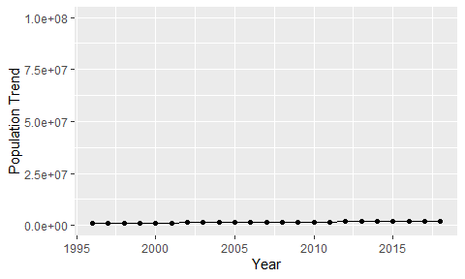

Political Stability Trend

# Population growth trend

The plot shows the population growth rate trend of the country.

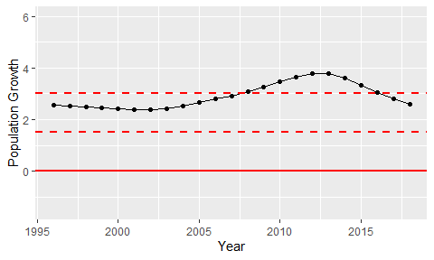

Population Growth Trend